Recreation and Data Disclaimer
This project is a recreated version of a project completed during one of my internships. Due to the confidential nature of the original financial data and systems, synthetic data and a local SQL Server Environment were used to reproduce the data-processing and reporting workflow. The data set used differs substantially in structure, values, volume, and appearance from the original organizational data. The project follows the same general approach used during the internship, including SQL-based data preparation. This recreation is only intended to demonstrate the process, technical approach, and reporting objective of the original project and not to reproduce the original dataset itself.
VENDOR OUTSTANDING BALANCE DASHBOARD

by Ishina Labit


PROJECT OBJECTIVE
The objective of the project is to improve the visibility and accuracy of vendor outstanding balance reporting in support of the company’s finance and accounting departments and their operations. The solution enables users to analyze outstanding balances by Buyer Group IDs and quickly identify high-balance accounts.

DATA SOURCE
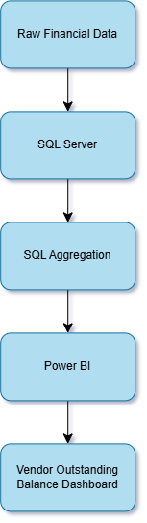
Figure 1: Data processing architecture

The data source for this project is a simplified version of the dataset I originally worked with. This project includes a table with 10,000 rows of synthetic financial transactional data containing information about vendors, Buyer Group IDs, invoices, payments, and transaction dates.
Below are the columns and their respective descriptions:
TRANSACTION TABLE VIEW
TransactionID | Key identifying a specific financial transaction
VendorID | Key that helps identify the vendors in the transaction
Vendor Name | Name of the vendor filed in the system
BuyerGroupID | Identifies buyers (customers) who are treated as a single purchasing group
InvoiceID | A specific invoice billed to a buyer from the vendor
Invoice Date | Date when the transaction takes place
Due Date | Date when the buyer is expected to settle the bill before incurring penalties
Invoice Amount | A monetary transactional amount expected to be paid by the buyer to the vendor
Paid Amount | How much a buyer has paid per transaction
Outstanding Balance | Calculated by [Invoice Amount] – [Paid Amount]
PaymentStatus | Is classified as one of: Outstanding, Partially Paid, or Paid

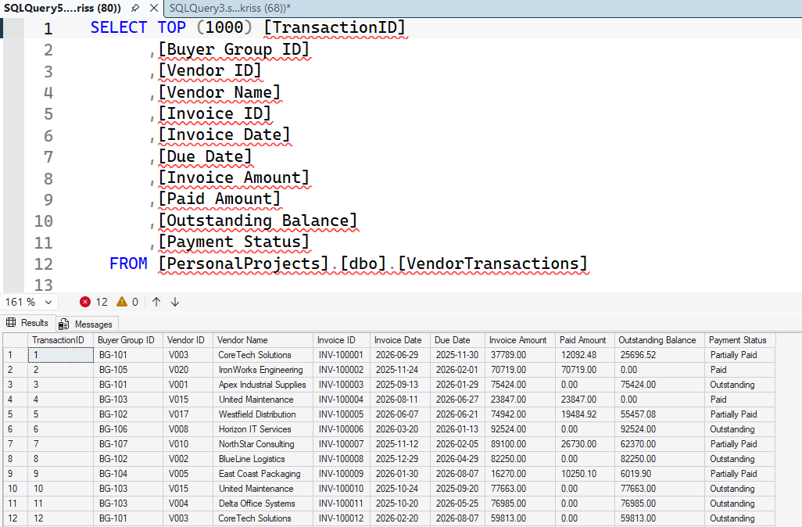
Figure 2: SSMS view of the Transactions table

SQL DATA PREPARATION
The SQL Server was set up in a local environment where the dataset, VendorTransaction, was created. The data contained in VendorTransactions is entirely synthetic and was generated specifically for this recreation.
The VendorTransactions table was used as the transaction-level dataset. SQL was then used to aggregate the transaction data by Buyer Group ID and Vendor ID. A SQL view, vw_OutstandingBalance, was created to aggregate the transaction-level data into a reporting-ready format, allowing Power BI to efficiently access the relevant financial information for analysis and visualization.
The following SQL syntax was used to create the view:
CREATE VIEW vw_OutstandingBalances AS
SELECT
[Buyer Group ID],
[Vendor ID],
[Vendor Name],
COUNT(DISTINCT [Invoice ID]) AS InvoiceCount,
SUM([Invoice Amount]) AS TotalInvoiceAmount,
SUM([Paid Amount]) AS TotalPaidAmount,
SUM([Outstanding Balance]) AS OutstandingBalance
FROM VendorTransactions
GROUP BY
[Buyer Group ID],
[Vendor ID],
[Vendor Name];

POWER BI CONNECTION
After creating the OutstandingBalances view, Power BI is then connected to the local SQL Server using the SQL Server connector. Instead of importing the raw transaction table, the view was used as the primary data source for the Power BI dashboard, reducing the amount of data required for the visualizations.

DASHBOARD DESIGN
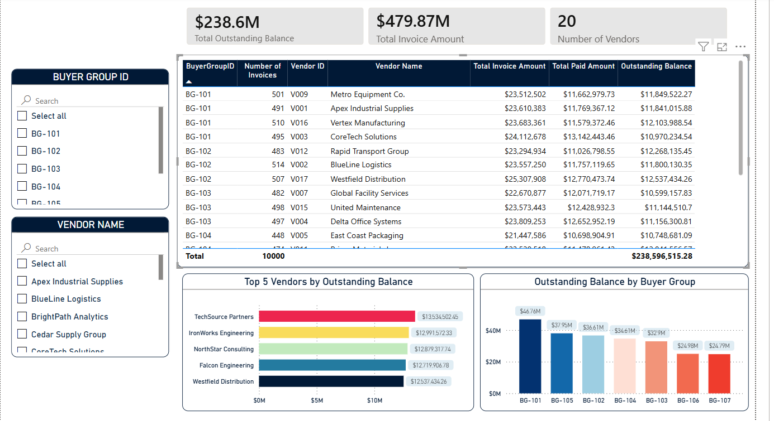
Figure 3: Vendor Outstanding Balance Dashboard
The dashboard design includes a table visualization of the OutstandingBalance SQL view, a horizontal bar chart for the Top 5 Vendors by Outstanding Balance, and a bar chart highlighting the Outstanding Balance per Buyer Group. Above the charts are cards showing the Total Outstanding Balance, Total Invoice Amount, and the Total Number of Vendors. For easier filtering, slicers for Buyer Group IDs and Vendor Names were included.

DATA VALIDATION
To validate the accuracy of the dashboard, aggregate outstanding balances were compared between the VendorTransactions table and Power BI.
 | SQL Result | Power BI Result
Total Outstanding Balance | $238,596,515.28 | $238,596,515.28
Number of Vendors | 20 | 20
Buyer Group  BG-102 | $36,605,700.06 | $36,605,700.06

Below is the SQL syntax used to validate the information:
-- Total Outstanding Validation
SELECT SUM([Outstanding Balance])
FROM VendorTransactions

-- Outstanding Balance for BG-102
SELECT
[Buyer Group ID],
SUM([Outstanding Balance]) AS [Total Outstanding Bal]
FROM VendorTransactions
WHERE [Buyer Group ID] = 'BG-102'
GROUP BY [Buyer Group ID];

-- Total Number of Vendors
SELECT
COUNT(DISTINCT([Vendor ID])) AS Total Number of Vendors
--FROM VendorTransactions

OUTCOME
The resulting Power BI dashboard provides a centralized view of vendor outstanding balances per Buyer Group ID. By utilizing SQL data transformation and aggregation, the dashboard solution improves reporting efficiency and enables users to quickly identify high-balance vendor accounts.

